**Does temperature stress cause wasting symptoms in giant California sea cucumbers?**

by

Declan Taylor and Jonathan Farr

A report submitted in partial fulfilment of the requirements of

DIRECTED STUDIES AND APPLIED DATA ANALYSIS

at

Bamfield Marine Sciences Centre

Instructors: Daniel Wuitchik and Dr. Sara Wuitchik

Teaching Assistant: Jenna Fleet

© Declan Taylor, 12/2021

Home University: The University of British Columbia

© Jonathan Farr

Home University: University of Alberta

# Abstract

Marine heat waves and warming oceans have profound effects on disease dynamics in marine invertebrates. Wasting diseases, potentially worsened by extreme heat events, have devastated sea stars across the Pacific Northwest coast. Recent evidence has emerged of wasting disease symptoms similar those in sea stars in giant California sea cucumbers (*Apostichopus californicus*). A severe sea cucumber wasting event of unknown cause occurred in Nanoose Bay, B.C. following an extreme climatic heat event. Our study aimed to determine whether heat stress as a single factor could trigger wasting in *A. californicus*. We also aimed to assess how two unusual sea cucumber characteristics, stiffening and evisceration, are affected by thermal stress. In a controlled laboratory setting, we exposed *A. californicus* to a three-day simulated marine heat wave of either 17ºC or 22ºC compared to a 12ºC control. We measured the presence of skin ulcers, mortality, stiffness for posture maintenance and antipredator defense, spawning, and evisceration. Treatment-related differences in responses to thermal stress were analyzed using Kruskal-Wallis tests and model selection processes. While we observed both minor and major handling ulcers, no wasting-like symptoms were exhibited in any temperature treatments. Mortality in the 22ºC treatment demonstrated that *A. californicus* were under extreme thermal stress during our experiment. Stiffening behaviour was significantly affected by heat treatments, suggesting that the muscle and mutable collagenous tissue responsible for stiffening were impaired by thermal stress. We also found further evidence in support of seasonal evisceration or atrophy of digestive organs. Our study provides evidence that wasting is not solely triggered by heat stress, leaving the cause of the mass mortality event observed in Nanoose unknown. *A. californicus* are ecologically and economically important marine detritovores, and to better understand and predict future mortality events, the causal agents of sea cucumber wasting must be identified.

# Keywords

Wasting disease, echinoderm, sea cucumber, skin ulceration syndrome, thermal stress

# Introduction

Anthropogenic climate change is increasing the intensity, duration, size and frequency of marine heat waves across the globe with potentially catastrophic effects on organism fitness, marine ecosystems, and human economies (Allan et al., 2021; Frölicher et al., 2018). These extreme climatic events often cause immediate and mass mortality at all trophic levels from thermal stress, starvation, toxicity, and hypoxia (Cavole et al., 2016; Di Lorenzo & Mantua, 2016; Suryan et al., 2021; von Biela et al., 2019). For example, the 2014-2015 warm water anomaly in the Northeast Pacific Ocean damaged tuna, salmon, and shellfish fisheries, caused mass mortalities in zooplanktonic primary consumers, and indirectly caused the starvation of species from salmon to seabirds (Cavole et al., 2016; Di Lorenzo & Mantua, 2016; Frölicher et al., 2018; von Biela et al., 2019). Marine heat waves can also impact marine ecosystems more subtly by impacting biological processes including foraging and movement behaviour (Chiu et al., 2021), reproduction (Shanks et al., 2020), and disease dynamics (Aalto et al., 2020).

Marine heat waves can worsen marine diseases and epidemics in part because thermal stress can compromise organism’s immune response (Branco et al., 2012; Matozzo et al., 2012). In addition, the virulence of many marine diseases appears to be regulated through temperature effects on pathogen transmission and growth (Marcogliese, 2008; Rubio-Portillo et al., 2016). For instance, the appearance and outbreak of Pacific Oyster Mortality Syndrome in Tasmania has been linked to marine heatwaves (Oliver et al., 2017). Many marine bacterial pathogens, including those which affect dominant cover species such as corals and macroalgae, also display temperature-dependent virulence (Case et al., 2011). Anomalously warm temperatures have also been accredited to triggering and exacerbating sea star wasting disease (Aquino et al., 2021; Bates et al., 2009; Eisenlord et al., 2016; Harvell et al., 2019; Hewson et al., 2018). Over the past decade, sea star wasting disease has affected more than 20 sea star species in the Northeast Pacific Ocean (Hewson et al., 2018). Sea star wasting is described as a broad set of symptoms including twisted arms, lesions, deflation/loss of turgor, loss of arms, lack of grip strength in tube feet, and liquefaction (Bates et al., 2009; Hewson et al., 2018; Menge et al., 2016). Unfortunately, recent evidence has emerged that wasting may occur in echinoderms other than sea stars.

Giant California sea cucumbers (*Apostichopus californicus;* Stimpson, 1857) are echinoderms of the class Holothuroidea and have been reported to display wasting symptoms similar to those of their sea star relatives. These benthic detritivores are found from the Gulf of Mexico to Alaska, and since 2014, small numbers of *A. californicus* with wasting symptoms have reported throughout their range (Hewson et al., 2020). Symptoms of wasting in sea cucumbers are anecdotally reported as similar to those observed in sea stars: non-focal lesions and fissures across the body wall, epidermal tissue sloughing, and rapid liquefaction (Hewson et al., 2020). A recent wasting event with very high mortality occurred in Nanoose, B.C., Canada, from August to October 2021 (Em Lim, *personal communication*). At its peak, up to 94% of all observed *A. californicus* at a single site showed evidence of wasting. On average, across all affected sites, 50% of observed *A. californicus* had wasting symptoms. Healthy individuals were often only seen below depths of 15 meters (Em Lim, *personal communication*). Southwest British Columbia was affected by multiple heat waves in the months leading up to this wasting outbreak (Environment & Climate Change Canada, 2021), and these extreme air temperatures led to elevated subtidal temperatures in the Strait of Georgia where Nanoose Bay is located (Ocean Networks Canada Data Archive, 2021). As such, there is a potential link between thermal stress and wasting in *A. californicus*, especially given that wasting was mostly observed at shallower, and therefore warmer depths*.* Understanding if wasting and temperature are connected requires knowledge of the unique behavioural and physiological characteristics of *A. californicus*.

Sea cucumbers have several unusual and poorly understood traits that distinguish them from other echinoderms such as sea stars, and may make their responses to thermal stress unique. Under normal seawater conditions, sea cucumbers can rapidly stiffen by contracting their longitudinal muscle and by changing the structure of their mutable collagenous tissue (Gao & Yang, 2015; Yamada et al., 2010). This is done in response to environmental stimuli, particularly for posture maintenance and predator defense (Motokawa & Tsuchi, 2003; Yamada et al., 2010). Another unique behaviour of sea cucumbers is evisceration, the ability to expulse and subsequently regenerate their digestive tract (Fankboner & Cameron, 1985). The mechanisms behind evisceration are poorly understood but include seasonality, as a response to the low-productivity winter months (Swan, 1961); predator defense (Ding et al., 2019); and disease stress (Deng et al., 2008). Evisceration may have unknown physiological consequences, and Hewson et al. (2020) proposed that seasonal evisceration may be linked to wasting disease due to their temporal overlap.

Considering recent marine heat waves and reports of a sea cucumber wasting outbreak in Nanoose Bay, this study assesses whether thermal stress as an isolated factor causes wasting symptoms in *A. californicus*. We also aim to evaluate how *A. californicus* behaviours like stiffening, spawning, and evisceration are affected by extreme temperatures to understand if they may relate to sea cucumber thermal stress, and potentially also to wasting. We hypothesized that prolonged elevated temperature exposure will cause wasting symptoms, mortality, and behavioural changes due to physiological stress. Based on our hypothesis, we make three predictions: 1) we will observe wasting symptoms only in high temperatures; 2) we will observe greater mortality with higher temperatures; and 3) we will observe decreased stiffening, and increased stress spawning and evisceration in elevated temperature treatments.

# Materials and Methods

Study organisms

*Apostichopus californicus* specimens were collected in July 2021 by divers Em Lim and Siobhan Gray in Scott’s Bay and at the entrance to Bamfield Inlet in Barkley Sound, British Columbia (48°50'02"N, 125°08'45"W). All were gathered from the shallow subtidal, between 7m and 12m depth. We placed the specimens in 19cm deep flow-through sea tables at the Bamfield Marine Sciences Centre. Each table had a constant flow of seawater from Barkley Sound. The *A. californicus* specimens were fed with kelp, plankton culture, and bloodworms. The specimen remained in the lab for four months prior to the start of the experiment. As part of a separate study, individuals were implanted with several types of tags and monitored; the results of this study indicated that the tags did not affect the organism’s behaviour or survival (Lim et al., unpublished data).

We measured organism size as some studies have shown that body size can affect the thermal tolerance of marine organisms (Di Santo & Lobel, 2017; Kelley et al., 2011). We weighed each sea cucumber twice, 24 hours apart, to get an average wet weight. Prior to the start of the experiment, we isolated individuals into separate containers for 24 hours to determine if they were defecating, and we continued to monitor defecation status throughout the experiment. Defecation was considered to be indicative of loss or atrophy of digestive organs (Fankboner & Cameron, 1985; Swan, 1961).

Experimental Design

We exposed 56 *A. californicus* specimens to one of three temperature treatments: 12ºC (n = 19), 17ºC (n = 19), or 22ºC (n = 18). The 12ºC control treatment represents the average seawater temperature 50m below the surface in Barkley Sound, while 17ºC mimics a high subtidal temperature under climate change scenarios, and 22ºC represents an extreme heat event that is unlikely to occur under natural circumstances (Chen et al., 2021; Pawlowicz, 2017; Xuereb et al., 2018). Individuals were separated into 30 bins with 2 specimens in each (except 4 bins in which only housed one).  We used a water-permeable divider to separate cucumbers within bins to allow for individual identification throughout the experiment. Each treatment consisted of two sea tables with a total of 10 bins. Individuals were randomly assigned to bins, and bins were randomly assigned to sea tables. The bins sat in 5cm deep water baths that were either at the temperature of the sea tables’ flow through system (12ºC), standing at ambient (room) temperature (17ºC), or heated with two 800W aquarium heaters to 24ºC to keep the bins at 22ºC. In the 22ºC treatment, the water bath was circulated around the sea table with powerhead aquarium pumps to ensure even temperature distribution. We monitored temperature in every bin at least twice daily.

The temperature treatment began at 09:00 on day 1 (Nov 09) and bucket temperature was ramped up slowly over 24h. Buckets remained at target temperatures until 16:00 on day 4 (Nov 12) after which they were slowly lowered until seawater flow was restored at 01:00 on day 5 (Nov 13). In summary, temperatures were elevated for a total of 103 hours, and treatments were at their target temperatures for 79 hours from days 2 to 4.  We did not feed the sea cucumbers during the experiment.  Water changes were done as need to keep nitrate and ammonium levels below 0.5 ppm, and new sea water was heated to the appropriate treatment temperature prior to water changes.

Measuring Sea Cucumber Wasting and Stress

We assessed all *A. californicus* for wasting symptoms throughout the experiment and counted skin ulcers on days 4, 5, 6, and 12. We classified skin ulcers as either minor or major ulcers based on their size and visual appearance (Fig. 1). We considered minor ulcers to be small lesions on the ends of spines, which did not have severe discoloration, and where the dermis was not fully removed. Scars and closed ulcers were not counted. We considered major ulcers to be open wounds that had fully worn through the dermis, where white tissue could be seen beneath. We also calculated the maximum number of minor and major ulcers observed on an individual at any single time point in the experiment.

We assessed body stiffness for antipredator defense and posture maintenance using two different 3-point ordinal scales. First, to assess antipredator defense stiffening, we gently picked up and palpated the organism for 10 seconds to mimic an attempted predation event. We assigned a score of 0 if the organism failed to stiffen and felt like the texture of body fat (soft), a score of 1 if it stiffened to the level of un-flexed muscle (moderate), and a score of 2 if it was comparably stiff to a flexed bicep muscle (stiff). Secondly, we removed each individual from their bucket and placed them on an elevated platform to measure their ability to maintain their posture over 5 seconds. We assigned a score of 0 if the organism failed to stiffen at all (soft), a score of 1 if it failed to remain stiff when placed on the platform (moderate), a and a score of 2 if it maintained its posture for the entire 5 seconds (stiff; Fig. 2). Stiffness was measured on days 1-5 of the experiment (as a baseline and throughout the treatment), and on days 7 and 12 after 48h and 7-days of recovery after the termination of the temperature treatment.

We checked the buckets every 12 hours to determine if spawning had occurred, since heat stress-induced spawning has been reported in other sea cucumber species (Battaglene et al., 2002). We could only measure spawning per-bucket (*N*buckets= 30) instead of per-cucumber because the gametes, especially sperm, would flow from one side of the bucket to the other and we were unable to determine which of the cucumbers had spawned*.* We also evaluated whether specimens had eviscerated based on the presence or absence of ejected internal organs (viscera).

Statistical Methods

We examined the difference between bucket temperatures during peak treatment days (day 2, 3 and 4) using a Kruskal-Wallis (K-W) test followed by a Dunn’s Kruskal-Wallis (Dunn’s K-W) test for multiple comparisons.

To assess which variables affected the maximum number of minor ulcers, we used a generalized additive model. Using the function *fitdist* from package GAMLSS (Rigby et al., 2021), we determined that the number of minor ulcers best fit a geometric distribution. We modelled the maximum number of minor ulcers as a function of treatment, weight, evisceration (binary), and defecation status (binary). We included sea table and bucket as random effects. We used backwards selection to determine the combination of variables that best explained the maximum number of ulcers.

To examine how sea cucumber mortality varied across temperature treatments we used a KW test followed by a Dunn’s K-W test for multiple comparisons. We further examined the covariates that affect the likelihood of mortality with a logistic regression model with cucumber mortality (binary) as the response variable and evisceration, defecation status, initial droop and squeeze scores, and initial weight as explanatory variables. We used backwards model selection to investigate which combination of these variables best explained the variation in sea cucumber mortality.

We determined if the two ordinal stiffness metrics (antipredator response and posture maintenance) were correlated using Spearman’s rank correlation coefficient (Schober & Schwarte, 2018). We assumed that these metrics represent two different behaviours, regardless of correlation strength, and therefore constructed separate models with each metric as the response variable. For both response variables, we constructed full ordinal regression models with the following predictor variables: temperature treatment, date (as a discrete variable), and the interaction term between treatment and date. We restricted stiffness measurements to those taken before the heat treatment began (day 1), during the treatment (days 2-4) and immediately after the heat treatment (day 5). We included individual identity as a random effect to account for repeated measures on the same individuals over time. We also included bucket ID and sea table ID as random effects to account for our paired (two sea cucumbers per bucket) and blocked (five buckets per sea table) experimental design. We used model selection to determine the most parsimonious models (ΔAIC > 2).

We used a K-W test to compare the number of buckets with spawning cucumbers across temperature treatments. For evisceration, we created a logistic regression model with treatment, weight, and defecation status as explanatory variables in the full model, and sea table as a random effect. We conducted backwards model selection to determine the most explanatory variables.

All statistical analyses were conducted in R version 4.0.3 (R Core Team, 2018). Dunn’s K-W tests were conducted with the *dunnTest* function in package FSA (Derek et al., 2021). Models for minor ulcers, mortality and evisceration were conducted using the *gamlss* function, and model selection was done using the *stepGAIC* function, both from package GAMLSS (Rigby et al., 2021). Ordinal regression models were conducted using the *clmm* function in package ordinal (Christensen, 2019); model selection for these models was conducted using the *dredge* function in package MuMIN (Barton & Barton, 2020). We considered results to be significant at p < 0.05 or if 95 % confidence intervals did not overlap zero.

# Results

The temperature treatments varied slightly from the target temperatures during the experimental heatwaves (Fig. 3). During the peak treatment days the mean temperature of the 12°C treatment was 12.4°C and varied from 10.8 - 14.0°C; the mean of the 17°C treatment was 16.6°C and ranged from 14.8°C to 17.9°C; the mean of the 22°C treatment was 21.7°C and varied from 19.6°C to 23.3°C. Temperature treatments on peak treatment days were significantly different from each other (K-W χ2 = 463.32, df = 2, p < 2.2e-16).

Skin ulcers occurred during the experiment in all three treatments. Minor ulcers were observed on 17 *A. californicus* in the 12ºC treatment, 15 individuals in the 17ºC treatment, and 10 individuals in the 22ºC treatment (Fig. S1). Major ulcers were observed in only the 22ºC treatment: on the final day of the treatment, two specimens had 1 and 4 ulcers respectively, the maximum major ulcer count observed. Neither of these individuals died; their major ulcers appeared to heal throughout the recovery period and were re-classified as minor ulcers on day 12 of the experiment. The maximum number of minor ulcers per individual was not significantly explained by treatment, weight, evisceration, or defecation status, because all explanatory variables were excluded from the final (null) backward-selected model.

Five mortalities occurred in the 22°C treatment on day 3 (n = 2), day 4 (n = 1), day 6 (n = 1) and day 7 (n = 1) of the experiment. Mortality was significantly different across temperature treatments (K-W χ2 = 11.383, df = 2, p = 0.00337). There was no significant difference between the 12°C and 17°C treatments (Dunn’s K-W Z = 0, p-adj = 1), but the 22°C treatment had significantly higher mortality than the 12°C (Dunn’s K-W Z = 2.935, p-adj = 0.00334) and 17°C (Dunn’s K-W Z = -2.935, p-adj = 0.00334) treatments. Based on backwards selection, our null model was the best fit, indicating that evisceration, defecation status, initial droop and squeeze scores, and weight did not significantly predict mortality in the 22°C treatment.

*A. californicus* body stiffness, as measured by antipredator response and posture maintenance, was lower in the 22ºC and 17ºC treatments compared to the 12ºC treatment (Fig. 3, 4). Antipredator response and posture maintenance were significantly positively correlated with each other (rs = 0.53, p < 0.001; Fig. S2). Backward-selected models indicated that temperature treatment and day affected both stiffness metrics (Table S1, S2). There was a significantly lower likelihood of high antipredator stiffness values for the 17°C (p = 4.80e-5) and 22°C (p = 5.88e-9) treatments relative to the control. Sea cucumber antipredator stiffness scores were significantly likely to be lower on day 2 (p = 1.16e-6), day 3 (p = 1.33e-7), day 4 (p = 2.06e-6) and day 5 (p = 5.05e-8) than on day 1 (Table S1). For structural stiffness, cucumbers were significantly less likely to have high stiffness scores relative to the control treatment in the 17°C (p = 1.99e-7) and 22°C (p = 2.44e-11) treatments. Structural stiffness values were significantly likely to be lower than day 1 on day 3 (p = 1.37e-5), day 4 (p = 2.50e-5) and day 5 (p = 8.66e-5), but not on day 2 (p = 0.0627; Table S2). In both antipredator and structural stiffness metrics, there were no significant differences in the likelihood of low stiffness values between the 17°C and 22°C treatments, as indicated by the high degree of overlap in 95% confidence intervals (Fig. S3).

Over the course of the experiment, evidence of stress spawning (eggs or sperm) occurred in 11 buckets. Nine of these buckets were in the 17ºC and 22ºC treatments. There was no significant difference in per-bucket spawning between temperature treatments (K-W χ2 = 1.94, df = 2, p = 0.379).

We observed 12 specimens eviscerate their digestive organs in the 12 ºC (n = 2), 17ºC (n = 5) and 22ºC (n = 5) treatments. Logistic regression results indicated that treatment temperature does not explain a significant amount of the variance in evisceration, because it was excluded from our backwards selected model (Table S3). However, weight (p = 0.0383) and defecation status (p = 0.0163) were included in the top model as significant predictors of evisceration (Table S3). Two individuals in the heat treatment eviscerated their respiratory trees in addition to their internal organs (Fig. 6). One mortality occurred 12 hours after respiratory evisceration, while the other was observed 68 hours after. The latter specimen was severely impacted by the evisceration of the respiratory tree as it was completely limp for the remaining days until it died.

# Discussion

The objective of our study was to determine if heat stress can induce wasting symptoms in *Apostichopus californicus*. Our hypothesis that thermal stress would trigger wasting symptoms, mortality, and changes in behaviour was partially supported. We unexpectantly observed minor skin ulcers at all treatment levels, and major ulcers in the 22ºC treatment, neither of which were characteristic of wasting symptoms (Hewson et al., 2020; Fig. 1). Though we did not observe wasting symptoms, we observed mortality in the high temperature treatment and a decrease in stiffness in the elevated temperature treatments, matching our predictions (Fig. 4, 5). These observations indicate that sea cucumbers were experiencing severe physiological stress, which was the proposed mechanism for mortality, loss of stiffness, and wasting. Spawning and evisceration were not significantly explained by temperature treatments, which did not align with our predictions.

Neither the minor or major ulcers that we observed matched the wasting symptoms reported in *A. californicus* in Nanoose Bay, B.C., or the isolated wasting events reported throughout the Pacific coast (Hewson et al., 2020). Both types of ulcers were very different from the white open lesions and fissures covering the whole bivium (dorsal) body wall of wasting *A. californicus* in Nanoose (Fig. 1). We also did not see any sloughing of body tissues or liquefaction, as has been anecdotally reported in previous literature (Hewson et al., 2020; Schroeder, 2017). The minor ulcers we observed on 42 *A. californicus* across treatments were small skin ulcers on the epidermis of the spines that did not break through the epidermal tissue. The major ulcers we observed on two *A. californicus* also did not match the full suite of wasting symptoms, though they bore a closer resemblance in colour, texture, and location (Fig. 1). These major ulcers fully wore through the epidermis, were white and oozing, and some were located on the bivium body wall as opposed to only on the ends of spines. Unlike reports of widespread mortality resulting from wasting in wild *A. californicus*,the major ulcers in both of our specimens healed within the 7-day recovery period. As such, there is no evidence that the sea cucumbers in our experiment were afflicted by the fatal wasting condition that has been previously reported (Hewson et al., 2020; Schroeder, 2017).

While we are uncertain of the ultimate cause of the ulcers that we observed, they may have been the product of intensive handling. During the experiment, specimens were handled daily and measured for their posture maintenance, increasing the frequency of abrasions on the epidermal surface tissue. Handling occurred equally across treatments, and we saw a matching distribution of *A. californicus* with ulcers (Fig. S1). Major ulcers may have begun as minor ulcers that had become infected in under high physiological stress caused by the 22°C treatment.

The strongest evidence that *A. californicus* were under extreme thermal stress in the 22ºC treatment was the mortality of five organisms, all in this treatment. We did not observe mortality of both *A. californicus* in a bucket, meaning that bucket water quality or contagious disease presence was unlikely to have affected mortality. Our findings therefore suggest that 22°C is close to the thermal tolerance of *A. californicus*, but 17ºC does not cause sufficient stress for mortality to occur. Although there are no studies on adult *A. californicus* thermal tolerance, our findings appear to coincidentally align with previous work on larval life stages. Ren et al. (2018) found that 22°C but not 16°C or 18°C temperatures harmed the survival, specific growth rate, and metamorphosis of larval *A. californicus*. Our findings add to Ren et al. (2018) and provide evidence that 22ºC is a physiologically detrimental temperature for both life stages. Beyond lethal effects, we also found evidence that high temperatures have extreme impacts on sea cucumber behaviour.

Both stiffening behaviours that we quantified were significantly affected by temperature, and were indicative of heat stress effects on two physiological processes: muscle contractions and dermal stiffening. Sea cucumbers have a band of longitudinal muscle along each ambulacral zone, and rings of circular muscle throughout the length body which allow them to contract and lengthen (Gao & Yang, 2015). Thermal stress causing muscular fatigue and relaxation (Dowd & Somero, 2013) may have conferred reduced stiffness. Stiffening is also caused by protein-mediated changes in mutable collagenous tissue within the dermis of sea cucumbers (Takehana et al., 2014). Based on the lack of stiffening observed at higher temperatures, heat stress may denature or decrease the production of the stiffening protein tensilin, or increase the production of the de-stiffening protein softenin (Takehana et al., 2014; Tamori et al., 2016; Yamada et al., 2010). Of note, the 17°C and 22°C treatments elicited similar stiffening responses, suggesting that both levels of thermal stress could affect the ability of *A. californicus* to maintain their posture and defend themselves from predation. A temperature-induced loss in stiffness may harm sea cucumber fitness by inhibiting their ability to avoid predation and maintain their posture while feeding or distributing gametes. Unlike stiffening behaviour, we did not find conclusive evidence that thermal stress affected spawning.

We did not observe any significant trends in spawning behaviour, however 9 of 11 spawning events occurred in elevated-temperature treatments. This trend, although insignificant, makes sense because Holothuroidea are known to stress-spawn (Battaglene et al., 2002; Rakaj et al., 2018; Schagerström et al., 2021). Our ability to connect spawning to individual *A. californicus* traits (e.g., size, stiffness, evisceration status) was limited due to the paired bucket experimental design. To better understand spawning, we would recommend keeping specimens in isolated containers to allow researchers to better track and identify spawning individuals.

Evisceration was measured on an individual basis, but behaviour appeared random across treatments; and this may have occurred because *A. californicus* in all treatments were responding to handling stimulation and stress during the experiment (Ding et al., 2019). However, model results provide evidence for other biological mechanisms that partially explain the non-treatment related variation in evisceration: weight and defecation status (Table S1). Defecation status in particular showed that *A. californicus* that were not defecating were more likely to eviscerate. This may have occurred because the energetic cost of eviscerating digestive organs would be lower for *A. californicus* that had already ceased using their organs, because they were either preparing to eviscerate (Swan, 1961) or undergoing viscera atrophy (Fankboner & Cameron, 1985). As such, when stressed by handling, *A. californicus* that had already begun seasonal reductions in digestive function were more likely to eviscerate from stress and overstimulation. Unlike digestive tract evisceration, we do not believe that the evisceration of the entire respiratory tree in two individuals in the 22ºC treatment was linked to seasonal senescence. For both individuals, respiratory evisceration was followed by mortality, and we infer that it was indicative of extreme physiological stress from extreme temperature.

Limitations

Our experiment had three limitations caused by the data collection methods. First, our measurement scale for body stiffness was qualitative and may have been subject to collection bias. To maximize the robustness of stiffness metrics, we standardized the data collection to one individual researcher (D. Taylor) and conducted quantitative ordinal regression analysis to determine if trends were significant. Second, we were unable to examine the virome and microbiome of *A. californicus* with skin ulcers, and cannot confirm that a viral or bacterial agent did not contribute to the presence of ulcers in our specimens. However, major ulcers were observed in separate buckets, providing no evidence of pathogen spread between specimens. Third, we only exposed specimens to the 17ºC and 22ºC treatment temperatures for 79 hours, and the majority of minor and major ulcers formed in the later days of our experiment. This indicates that a longer exposure to heat may have caused ulcers to continue to form and worsen in severity, and future studies should test various lengths of temperature stress. However, during our short-term experiment we observed significant physiological and behavioural responses to thermal stress. We expect that if wasting was induced by physiological heat stress as an isolated factor, it would have occurred under these conditions.

There are also genetic and temporal differences between our study specimens and those affected by the Nanoose wasting event. We obtained specimensfrom Bamfield, B.C., a population where wasting symptoms have never been recorded (Hewson et al., 2020). However, the Tofino B.C. *A. californicus* subpopulation (which likely includes Barkley Sound) is distinct from the Strait of Georgia populations. However, this subpopulation receives significant genetic influx from the *A. californicus* population in the Strait of Georgia where wasting has been reported (Xuereb et al., 2018), so we do not expect that genetic differentiation could confer differential vulnerability to wasting in our specimens compared to those in the Nanoose. In addition, our experiment was conducted in November 2021 after the wasting event in Nanoose Bay occurred between August and October 2021 (Em Lim, *personal communication*), and seasonal differences in *A. californicus* physiology may explain the lack of wasting symptoms. However, wasting in *A. californicus* has been reported year-round in other locations (Hewson et al., 2020), so we do not consider this to be a factor in interpreting our results.

Synthesis: Skin Ulceration in Sea Cucumbers

Although we observed skin ulcers under heat stress, thermal stress did not induce wasting. However, white skin ulcerations like the major ulcers we observed that we observed are a recognized condition in other Holothuroidea, described as a Skin Ulceration Disease or Skin Ulceration Syndrome (SUS; Delroisse et al., 2020). SUS has been documented in commercially farmed *Apostichopus japonicus* and *Holothuria scabra,* and has been characterized by white ulcers on both sides of the body wall (Deng et al., 2009; Li et al., 2012; Wang et al., 2007; Zhang et al., 2018). Based on the photographic evidence provided by Zhang et al. (2018) and Deng et al. (2009), minor SUS symptoms in *A. japonicus* and the major ulcers in our *A. californicus* specimens are visually similar (Fig. 1). Unlike the SUS symptoms reported in *A. japonicus*, we did not see any indication of swelling or discolouration of the peristomes, and we did not see an initial abundance of ulcers around the mouth or cloaca (Becker et al., 2004; Delroisse et al., 2020; Wang et al., 2007). *A. japonicus* and *A. californicus* are both temperate sea cucumbers of the *Apostichopus* genus with a similar life history strategy (Purcell et al., 2016), but because of their geographic and genetic differences we cannot conclusively apply knowledge about SUS to skin ulceration in *A. californicus*. Interestingly, extreme cases of SUS and wasting symptoms in *A. californicus* are also visually similar (Fig 1).

Research on skin ulceration conditions in other sea cucumber species may provide insight to the drivers of sea cucumber wasting as there are parallels between wasting in *A. californicus* and SUS in farmed sea cucumbers (Delroisse et al., 2020; Hewson et al., 2020). Severe cases of SUS have high transmissibility and mortality (Delroisse et al., 2020), and appear symptomatically similar to wasting outbreaks in *A. californicus*. For both SUS and wasting symptoms, the cause remains uncertain. In SUS, experiments have identified bacterial pathogenetic origins by sampling infected tissue and conducting injection experiments, but SUS has not been linked to any specific bacteria (Delroisse et al., 2020; Liu et al., 2010; Zhang et al., 2018). Viruses have also been considered as a potential causal agent based on affected tissue samples, but this has not been corroborated with injection experiments (Deng et al., 2009; Liu et al., 2010; Wang et al., 2007). A study examining a single wasting *A. californicus* found a high viral load, but was unable to identify a specific pathogen causing wasting symptoms (Hewson et al., 2020). The lack of certainty on the causal agent(s) of SUS, wasting symptoms, and the ulcers that we observed demands further investigation.

Since we observed skin ulcers under heat stress that did not amount to wasting, other factors must be causing recent wasting outbreaks in *A. californicus*. Future research on wasting should investigate the potential for shared pathology with SUS, given the symptomatic similarities. Furthermore, studies should investigate the potential for a pathogenic causal agent, as this has been previously linked to wasting-like symptoms both in other sea cucumbers (Deng et al., 2008, 2009; Liu et al., 2010) and sea stars (Hewson et al., 2014, 2018; Work et al., 2021). Abiotic factors that may act alone or in combination with pathogenic agents to trigger wasting in *A. californicus* should also be further investigated. Studies conducted on historically asymptomatic populations that are isolated from wasting outbreaks (e.g., Bamfield) could provide insight into whether the causal agents of wasting are naturally present in the *A. californicus* virome/microbiome. Biotic factors (viral, bacterial) and abiotic factors (chemical pollution, hypoxia, eutrophication) should both be investigated because widespread environmental degradation and climate change are generating multifactorial pathogenic dynamics across the world (Allan et al., 2021; Marcogliese, 2008).

Conclusion

In this study we subjected *A. californicus* to extreme thermal stress, as measured by mortality and degraded stiffening behaviour. Despite this, we found no evidence that wasting is triggered by temperature stress in the absence of pathogenic agents. The August 2021 mass wasting event in Nanoose (Em Lim, *personal communication*) remains unexplained. Wasting in sea stars has been widespread and extremely destructive (Hewson et al., 2014, 2018; Work et al., 2021), and determining the factors that cause and exacerbate wasting in *A. californicus* will be essential for predicting and managing mortality events. Sea cucumbers are ecologically important benthic detritivores, which break down organic matter, recycle nutrients, and maintain sediment health (Purcell et al., 2016; Wheeling et al., 2007). In North America, sea cucumber harvest is a growing industry (Hannah et al., 2013; van Dam-Bates et al., 2016) that is worth more than 10 million dollars in British Columbia alone (Fisheries and Oceans Canada, 2021). Efforts to protect, manage, and sustainably harvest giant California sea cucumbers in the face of global change will require a comprehensive understanding of their stress responses, disease dynamics, and the threat of novel sea cucumber wasting.

# Acknowledgments

We appreciate the opportunity this fall to learn about the territories we are visiting and the people who steward these lands. This project was conducted on the traditional territory of the Huu-ay-aht First Nations, a Nuu-chah-nulth Nation and signatory to the Maa-nulth First Nations Final Agreement. We would like to thank Daniel Wuitchik and Dr. Sara Wuitchik for their instruction and guidance from the beginning to end of this project. We would also like to thank Em Lim for sharing their data, ideas, and contagious enthusiasm about sea cucumbers. We would also like to thank Payton Arthur, Mike Chung, Gabrielle Languedoc, Sammie Foley, Juliane Jones, and Carter Burtlake for helpful comments on earlier versions of this manuscript.

References

Aalto, A., Lafferty, K. D., Sokolow, S. H., Grewelle, R., Boch, A., Bograd, S. J., Hazen, L., Jacox, M. G., & De Leo, G. A. (2020). Models with environmental drivers offer a plausible mechanism for the rapid spread of infectious disease outbreaks in marine organisms. Scientific Reports, 10(5975). https://doi.org/10.1038/s41598-020-62118-4

Allan, R. P., Arias, P. A., Berger, S., Canadell, J. G., Cassou, C., Chen, D., Cherchi, A., Connors, S. L., Coppola, E., Cruz, F. A., Diongue-Niang, A., Doblas-Reyes, F. J., Douville, H., Driouech, F., Edwards, T. L., Engelbrecht, F., Eyring, V., Fischer, E., Flato, G. M., … Zickfeld, K. (2021). IPCC: Climate Change 2021: The Physical Science Basis. *Cambridge University Press. In Press.*, 42. https://www.ipcc.ch/report/ar6/wg1/

Aquino, C. A., Besemer, R. M., DeRito, C. M., Kocian, J., Porter, I. R., Raimondi, P. T., Rede, J. E., Schiebelhut, L. M., Sparks, J. P., Wares, J. P., & Hewson, I. (2021). Evidence that microorganisms at the animal-water interface drive Sea Star Wasting Disease. *Frontiers in Microbiology*, *11*. https://doi.org/10.3389/fmicb.2020.610009

Barton, K., & Barton, M. K. (2020). Package MuMIn: Multi-model inference (1.43.17; Vol. 1, Issue 1, p. 18).

Bates, A. E., Hilton, B. J., & Harley, C. D. G. (2009). Effects of temperature, season and locality on wasting disease in the keystone predatory sea star *Pisaster ochraceus*. *Diseases of Aquatic Organisms*, *86*(3), 245–251. https://doi.org/10.3354/dao02125

Battaglene, S. C., Seymour, J. E., Ramofafia, C., & Lane, I. (2002). Spawning induction of three tropical sea cucumbers, *Holothuria scabra, H. fuscogilva* and *Actinopyga mauritiana*. *Aquaculture*, *207*(1–2), 29–47. https://doi.org/10.1016/S0044-8486(01)00725-6

Becker, P., Gillan, D., Lanterbecq, D., Jangoux, M., Rasolofonirina, R., Rakotovao, J., & Eeckhaut, I. (2004). The skin ulceration disease in cultivated juveniles of *Holothuria scabra* (Holothuroidea, Echinodermata). *Aquaculture*, *242*(1–4), 13–30. https://doi.org/10.1016/j.aquaculture.2003.11.018

Branco, P. C., Pressinotti, L. N., Borges, J. C. S., Iunes, R. S., Kfoury, R., da Silva, M. O., Gonzalez, M., dos Santos, M. F., Peck, L. S., Cooper, E. L., & da Silva, R. M. C. (2012). Cellular biomarkers to elucidate global warming effects on Antarctic sea urchin *Sterechinus neumayeri*. *Polar Biology*, *35*(2), 221–229. https://doi.org/10.1007/S00300-011-1063-5

Case, R. J., Longford, S. R., Campbell, A. H., Low, A., Tujula, N., Steinberg, P. D., & Kjelleberg, S. (2011). Temperature induced bacterial virulence and bleaching disease in a chemically defended marine macroalga. *Environmental Microbiology*, *13*(2), 529–537. https://doi.org/10.1111/j.1462-2920.2010.02356.x

Cavole, L. M., Demko, A. M., Diner, R. E., Giddings, A., Koester, I., Pagniello, C. M. L. S., Paulsen, M. L., Ramirez-Valdez, A., Schwenck, S. M., Yen, N. K., Zill, M. E., & Franks, P. J. S. (2016). Biological impacts of the 2013–2015 warm-water anomaly in the northeast Pacific: Winners, Losers, and the Future. *Oceanography*, *29*(2), 273–285. https://doi.org/10.5670/oceanog.2016.32

Chen, Z., Shi, J., Liu, Q., Chen, H., & Li, C. (2021). A persistent and intense marine heatwave in the Northeast Pacific during 2019–2020. *Geophysical Research Letters*, *48*(13). https://doi.org/10.1029/2021GL093239

Chiu, J. A., Bizzarro, J. J., & Starr, R. M. (2021). Trophic ecology of yellowtail rockfish (*Sebastes flavidus*) during a marine heat wave off Central California, USA. *PLoS ONE*, *16*(5 May). https://doi.org/10.1371/JOURNAL.PONE.0251499

Christensen, R. H. B. (2019). Package ordinal: Regression models for ordinal data (2019.12-10).

Delroisse, J., Van Wayneberghe, K., Flammang, P., Gillan, D., Gerbaux, P., Opina, N., Todinanahary, G. G. B., & Eeckhaut, I. (2020). Epidemiology of a SKin Ulceration Disease (SKUD) in the sea cucumber *Holothuria scabra* with a review on the SKUDs in Holothuroidea (Echinodermata). *Scientific Reports*, *10*(1). https://doi.org/10.1038/S41598-020-78876-0

Deng, H., He, C., Zhou, Z., Liu, C., Tan, K., Wang, N., Jiang, B., Gao, X., & Liu, W. (2009). Isolation and pathogenicity of pathogens from skin ulceration disease and viscera ejection syndrome of the sea cucumber *Apostichopus japonicus*. *Aquaculture*, *287*(1–2), 18–27. https://doi.org/10.1016/j.aquaculture.2008.10.015

Deng, H., Zhou, Z. C., Wang, N. Bin, & Liu, C. (2008). The syndrome of sea cucumber (*Apostichopus japonicus*) infected by virus and bacteria. *Virologica Sinica*, *23*(1), 63–67. https://doi.org/10.1007/S12250-008-2863-9

Derek, A., Doll, J., & Wheeler, P. (2021). Package FSA: Simple fisheries stock assessment methods (0.9.1).

Di Lorenzo, E., & Mantua, N. (2016). Multi-year persistence of the 2014/15 North Pacific marine heatwave. *Nature Climate Change*, *6*(11), 1042–1047. https://doi.org/10.1038/nclimate3082

Di Santo, V., & Lobel, P. S. (2017). Body size and thermal tolerance in tropical gobies. *Journal of Experimental Marine Biology and Ecology*, *487*, 11–17. https://doi.org/10.1016/J.JEMBE.2016.11.007

Ding, K., Zhang, L., Sun, L., Lin, C., Feng, Q., Zhang, S., Yang, H., Brinkman, R., Lin, G., & Huang, Z. (2019). Transcriptome analysis provides insights into the molecular mechanisms responsible for evisceration behavior in the sea cucumber *Apostichopus japonicus*. *Comparative Biochemistry and Physiology Part D: Genomics and Proteomics*, *30*, 143–157. https://doi.org/10.1016/J.CBD.2019.02.008

Dowd, W. W., & Somero, G. N. (2013). Behavior and survival of *Mytilus congeners* following episodes of elevated body temperature in air and seawater. *Journal of Experimental Biology*, *216*(3), 502–514. https://doi.org/10.1242/jeb.076620

Eisenlord, M. E., Groner, M. L., Yoshioka, R. M., Elliott, J., Maynard, J., Fradkin, S., Turner, M., Pyne, K., Rivlin, N., Van Hooidonk, R., & Harvell, C. D. (2016). Ochre star mortality during the 2014 wasting disease epizootic: Role of population size structure and temperature. *Philosophical Transactions of the Royal Society B: Biological Sciences*, *371*(1689). https://doi.org/10.1098/rstb.2015.0212

Environment & Climate Change Canada. (2021). Environment and Climate Change Canada warns western Canadians about dangerous record-high temperatures. 4–7. https://www.canada.ca/en/environment-climate-change/news/2021/06/environment-and-climate-change-canada-warns-western-canadians-about-dangerous-record-high-temperatures.html

Fankboner, P. V., & Cameron, J. L. (1985). Seasonal atrophy of the visceral organs in a sea cucumber. *Canadian Journal of Zoology*, *63*(12), 2888–2892. https://doi.org/10.1139/Z85-432

Fisheries and Oceans Canada. (2021). Integrated Fisheries Management Plan Summary, Sea Cucumber (*Apostichopus californicus*) By Dive, Pacific Region.

Frölicher, T. L., Fischer, E. M., & Gruber, N. (2018). Marine heatwaves under global warming. *Nature*, *560*(7718), 360–364. https://doi.org/10.1038/s41586-018-0383-9

Gao, F., & Yang, H. (2015). Chapter 4 - Anatomy. *Developments in Aquaculture and Fisheries Science*, *39*, 53–76. https://doi.org/10.1016/B978-0-12-799953-1.00004-0

Hannah, L., Pearce, C. M., & Cross, S. F. (2013). Growth and survival of California sea cucumbers (*Parastichopus californicus*) cultivated with sablefish (*Anoplopoma fimbria*) at an integrated multi-trophic aquaculture site. *Aquaculture*, *406*–*407*, 34–42. https://doi.org/10.1016/J.AQUACULTURE.2013.04.022

Harvell, C. D., Montecino-Latorre, D., Caldwell, J. M., Burt, J. M., Bosley, K., Keller, A., Heron, S. F., Salomon, A. K., Lee, L., Pontier, O., Pattengill-Semmens, C., & Gaydos, J. K. (2019). Disease epidemic and a marine heat wave are associated with the continental-scale collapse of a pivotal predator (*Pycnopodia helianthoides*). *Science Advances*, *5*(1), 1–9. https://doi.org/10.1126/sciadv.aau7042

Hewson, I., Bistolas, K. S. I., Quijano Cardé, E. M., Button, J. B., Foster, P. J., Flanzenbaum, J. M., Kocian, J., & Lewis, C. K. (2018). Investigating the complex association between viral ecology, environment, and northeast Pacific Sea Star Wasting. *Frontiers in Marine Science*, *5*(MAR). https://doi.org/10.3389/fmars.2018.00077

Hewson, I., Button, J. B., Gudenkauf, B. M., Miner, B., Newton, A. L., Gaydos, J. K., Wynne, J., Groves, C. L., Hendler, G., Murray, M., Fradkin, S., Breitbart, M., Fahsbender, E., Lafferty, K. D., Kilpatrick, A. M., Miner, C. M., Raimondi, P., Lahner, L., Friedman, C. S., … Harvell, C. D. (2014). Densovirus associated with sea-star wasting disease and mass mortality. *Proceedings of the National Academy of Sciences of the United States of America*, *111*(48), 17278–17283. https://doi.org/10.1073/PNAS.1416625111

Hewson, I., Johnson, M. R., & Tibbetts, I. R. (2020). An Unconventional Flavivirus and Other RNA Viruses in the Sea Cucumber (Holothuroidea; Echinodermata) Virome. *Viruses*, *12*(1057). https://doi.org/10.3390/v12091057

Kelley, A. L., de Rivera, C. E., & Buckley, B. A. (2011). Intraspecific variation in thermotolerance and morphology of the invasive European green crab, *Carcinus maenas*, on the west coast of North America. *Journal of Experimental Marine Biology and Ecology*, *409*(1–2), 70–78. https://doi.org/10.1016/J.JEMBE.2011.08.005

Lambert, P., 2021. *Apostichopus californicus* (Stimpson, 1857). In Klinkenberg, Brian. (Editor) 2021. *E-Fauna BC: electronic atlas of the fauna of British* Columbia [efauna.bc.ca]. Lab for Advanced Spatial Analysis, Department of Geography, University of British Columbia, Vancouver. [Accessed: 2021-12-15 1:32:12 PM]

Li, C., Feng, W., Qiu, L., Xia, C., Su, X., Jin, C., Zhou, T., Zeng, Y., & Li, T. (2012). Characterization of skin ulceration syndrome associated microRNAs in sea cucumber *Apostichopus japonicus* by deep sequencing. *Fish and Shellfish Immunology*, *33*(2), 436–441. https://doi.org/10.1016/j.fsi.2012.04.013

Liu, H., Zheng, F., Sun, X., Hong, X., Dong, S., Wang, B., Tang, X., & Wang, Y. (2010). Identification of the pathogens associated with skin ulceration and peristome tumescence in cultured sea cucumbers *Apostichopus japonicus* (Selenka). *Journal of Invertebrate Pathology*, *105*(3), 236–242. https://doi.org/10.1016/J.JIP.2010.05.016

Marcogliese, D. J. (2008). The impact of climate change on the parasites and infectious diseases of aquatic animals. *OIE Revue Scientifique et Technique*, *27*(2), 467–484. https://doi.org/10.20506/RST.27.2.1820

Matozzo, V., Chinellato, A., Munari, M., Finos, L., Bressan, M., & Marin, M. G. (2012). First evidence of immunomodulation in bivalves under seawater acidification and increased temperature. *PLoS ONE*, *7*(3). https://doi.org/10.1371/JOURNAL.PONE.0033820

Menge, B. A., Cerny-Chipman, E. B., Johnson, A., Sullivan, J., Gravem, S., & Chan, F. (2016). Sea star wasting disease in the keystone predator *Pisaster ochraceus* in Oregon: insights into differential population impacts, recovery, predation rate, and temperature effects from long-term research. *PLoS ONE*, *11*(5). https://doi.org/10.1371/journal.pone.0153994

Motokawa, T., & Tsuchi, A. (2003). Dynamic mechanical properties of body-wall dermis in various mechanical states and their implications for the behavior of sea cucumbers. *Biological Bulletin*, *205*(3), 261–275. https://doi.org/10.2307/1543290

Ocean Networks Canada Data Archive. (2021). *Ocean Networks Canada Temperature Data*. University of Victoria.

Oliver, E. C. J., Benthuysen, J. A., Bindoff, N. L., Hobday, A. J., Holbrook, N. J., Mundy, C. N., & Perkins-Kirkpatrick, S. E. (2017). The unprecedented 2015/16 Tasman Sea marine heatwave. *Nature Communications*, *8*(May), 1–12. https://doi.org/10.1038/ncomms16101

Pawlowicz, R. (2017). Seasonal cycles, hypoxia, and renewal in a coastal fjord (Barkley Sound, British Columbia). *Atmosphere - Ocean*, *55*(4–5), 264–283. https://doi.org/10.1080/07055900.2017.1374240

Purcell, S., Conand, C., Uthicke, S., & Byrne, M. (2016). Ecological roles of exploited sea cucumbers. *Oceanography and Marine Biology: An Annual Review*, *54*, 367–386. https://doi.org/10.1201/9781315368597-8

R Core Team (2018). R: A language and environment for statistical computing. R Foundation for Statistical Computing, Vienna, Austria. URL https://www.R-project.org/

Rakaj, A., Fianchini, A., Boncagni, P., Lovatelli, A., Scardi, M., & Cataudella, S. (2018). Spawning and rearing of *Holothuria tubulosa*: A new candidate for aquaculture in the Mediterranean region. *Aquaculture Research*, *49*(1), 557–568. https://doi.org/10.1111/ARE.13487

Ren, Y., Liu, W., & Pearce, C. M. (2018). Effects of stocking density, ration and temperature on growth, survival and metamorphosis of auricularia larvae of the California sea cucumber, *Parastichopus californicus*. *Aquaculture Research*, *49*(1), 517–525. https://doi.org/10.1111/ARE.13482

Rigby, R. A., Stasinopoulos, D. M., & Lane, P. W. (2021). Package gamlss: Generalized additive models for location, scale and shape. In *Journal of the Royal Statistical Society. Series C: Applied Statistics* (5.3-4). https://doi.org/10.1111/j.1467-9876.2005.00510.x

Rubio-Portillo, E., Izquierdo-Muñoz, A., Gago, J. F., Rosselló-Mora, R., Antón, J., & Ramos-Esplá, A. A. (2016). Effects of the 2015 heat wave on benthic invertebrates in the Tabarca Marine Protected Area (southeast Spain). *Marine Environmental Research*, *122*, 135–142. https://doi.org/10.1016/J.MARENVRES.2016.10.004

Schagerström, E., Christophersen, G., Sunde, J., Bakke, S., Matusse, N. R., Dupont, S., & Sundell, K. S. (2021). Controlled spawning and rearing of the sea cucumber, *Parastichopus tremulus*. *Journal of the World Aquaculture Society*. https://doi.org/10.1111/JWAS.12816

Schober, P., & Schwarte, L. A. (2018). Correlation coefficients: Appropriate use and interpretation. *Anesthesia and Analgesia*, *126*(5), 1763–1768. https://doi.org/10.1213/ANE.0000000000002864

Schroeder, L. (2017). Wasting-like lesions occurring on California sea cucumbers. *The Dredgings*, *57*(3), 3. www.PNWSC.org

Shanks, A. L., Rasmuson, L. K., Valley, J. R., Jarvis, M. A., Salant, C., Sutherland, D. A., Lamont, E. I., Hainey, M. A. H., & Emlet, R. B. (2020). Marine heat waves, climate change, and failed spawning by coastal invertebrates. *Limnology and Oceanography*, *65*(3), 627–636. https://doi.org/10.1002/LNO.11331

Suryan, R. M., Arimitsu, M. L., Coletti, H. A., Hopcroft, R. R., Lindeberg, M. R., Barbeaux, S. J., Batten, S. D., Burt, W. J., Bishop, M. A., Bodkin, J. L., Brenner, R., Campbell, R. W., Cushing, D. A., Danielson, S. L., Dorn, M. W., Drummond, B., Esler, D., Gelatt, T., Hanselman, D. H., … Zador, S. G. (2021). Ecosystem response persists after a prolonged marine heatwave. *Scientific Reports*, *11*(1), 1–17. https://doi.org/10.1038/s41598-021-83818-5

Swan, E. F. (1961). Seasonal evisceration in the sea cucumber, *Parastichopus californicus* (Stimpson). *Science*, *133*(3458), 1078–1079. https://doi.org/10.1126/science.133.3458.1078

Takehana, Y., Yamada, A., Tamori, M., & Motokawa, T. (2014). Softenin, a novel protein that softens the connective tissue of sea cucumbers through inhibiting interaction between collagen fibrils. *PLoS ONE*, *9*(1). https://doi.org/10.1371/JOURNAL.PONE.0085644

Tamori, M., Ishida, K., Matsuura, E., Ogasawara, K., Hanasaka, T., Takehana, Y., Motokawa, T., & Osawa, T. (2016). Ultrastructural changes associated with reversible stiffening in catch connective tissue of sea cucumbers. *PLoS ONE*, *11*(5). https://doi.org/10.1371/JOURNAL.PONE.0155673

van Dam-Bates, P., Curtis, D., Cowen, L., Cross, S., & Pearce, C. (2016). Assessing movement of the California sea cucumber *Parastichopus californicus* in response to organically enriched areas typical of aquaculture sites. *Aquaculture Environment Interactions*, *8*, 67–76. https://doi.org/10.3354/AEI00156

von Biela, V., Arimitsu, M. L., Piatt, J. F., Heflin, B. M., & Schoen, S. (2019). Extreme reduction in condition of a key forage fish during the Pacific marine heatwave of 2014–2016. *Marine Ecology Progress Series*, *613*, 171–182.

Wang, P., Chang, Y., Yu, J., Li, C., & Xu, G. (2007). Acute peristome edema disease in juvenile and adult sea cucumbers *Apostichopus japonicus* (Selenka) reared in North China. *Journal of Invertebrate Pathology*, *96*(1), 11–17. https://doi.org/10.1016/j.jip.2007.03.001

Wheeling, R. J., Verde, E. A., & Nestler, J. R. (2007). Diel cycles of activity, metabolism, and ammonium concentration in tropical holothurians. *Marine Biology*, *152*(2), 297–305. https://doi.org/10.1007/S00227-007-0683-3

Work, T. M., Weatherby, T. M., DeRito, C. M., Besemer, R. M., & Hewson, I. (2021). Sea star wasting disease pathology in *Pisaster ochraceus* shows a basal-to-surface process affecting color phenotypes differently. *Diseases of Aquatic Organisms*, *145*, 21–33. https://doi.org/10.3354/DAO03598

Xuereb, A., Benestan, L., Normandeau, É., Daigle, R. M., Curtis, J. M. R., Bernatchez, L., & Fortin, M. J. (2018). Asymmetric oceanographic processes mediate connectivity and population genetic structure, as revealed by RADseq, in a highly dispersive marine invertebrate (*Parastichopus californicus*). *Molecular Ecology*, *27*(10), 2347–2364. https://doi.org/10.1111/MEC.14589

Yamada, A., Tamori, M., Iketani, T., Oiwa, K., & Motokawa, T. (2010). A novel stiffening factor inducing the stiffest state of holothurian catch connective tissue. *Journal of Experimental Biology*, *213*(20), 3416–3422. https://doi.org/10.1242/JEB.044149

Zhang, Z., Xing, R., Lv, Z., Shao, Y., Zhang, W., Zhao, X., & Li, C. (2018). Analysis of gut microbiota revealed *Lactococcus garviaeae* could be an indicative of skin ulceration syndrome in farmed sea cucumber *Apostichopus japonicus*. *Fish and Shellfish Immunology*, *80*(May), 148–154. https://doi.org/10.1016/j.fsi.2018.06.001

# Tables and Figures

**Fig. 1.** Various skin ulcerations present in sea cucumbers. A) and B) are minor and major ulcers (respectively) observed in *Apostichopus californicus* during our experiment. C) *Apostichopus japonicus* with mild symptoms of Skin Ulceration Syndrome (SUS; Zhang et al., 2018). D) *Holothuria scabra* with major SUS symptoms (Delroisse et al., 2020). E) *A. californicus* with sea cucumber wasting symptoms observed in Nanoose Bay, B.C. (Em Lim, *personal communication*).

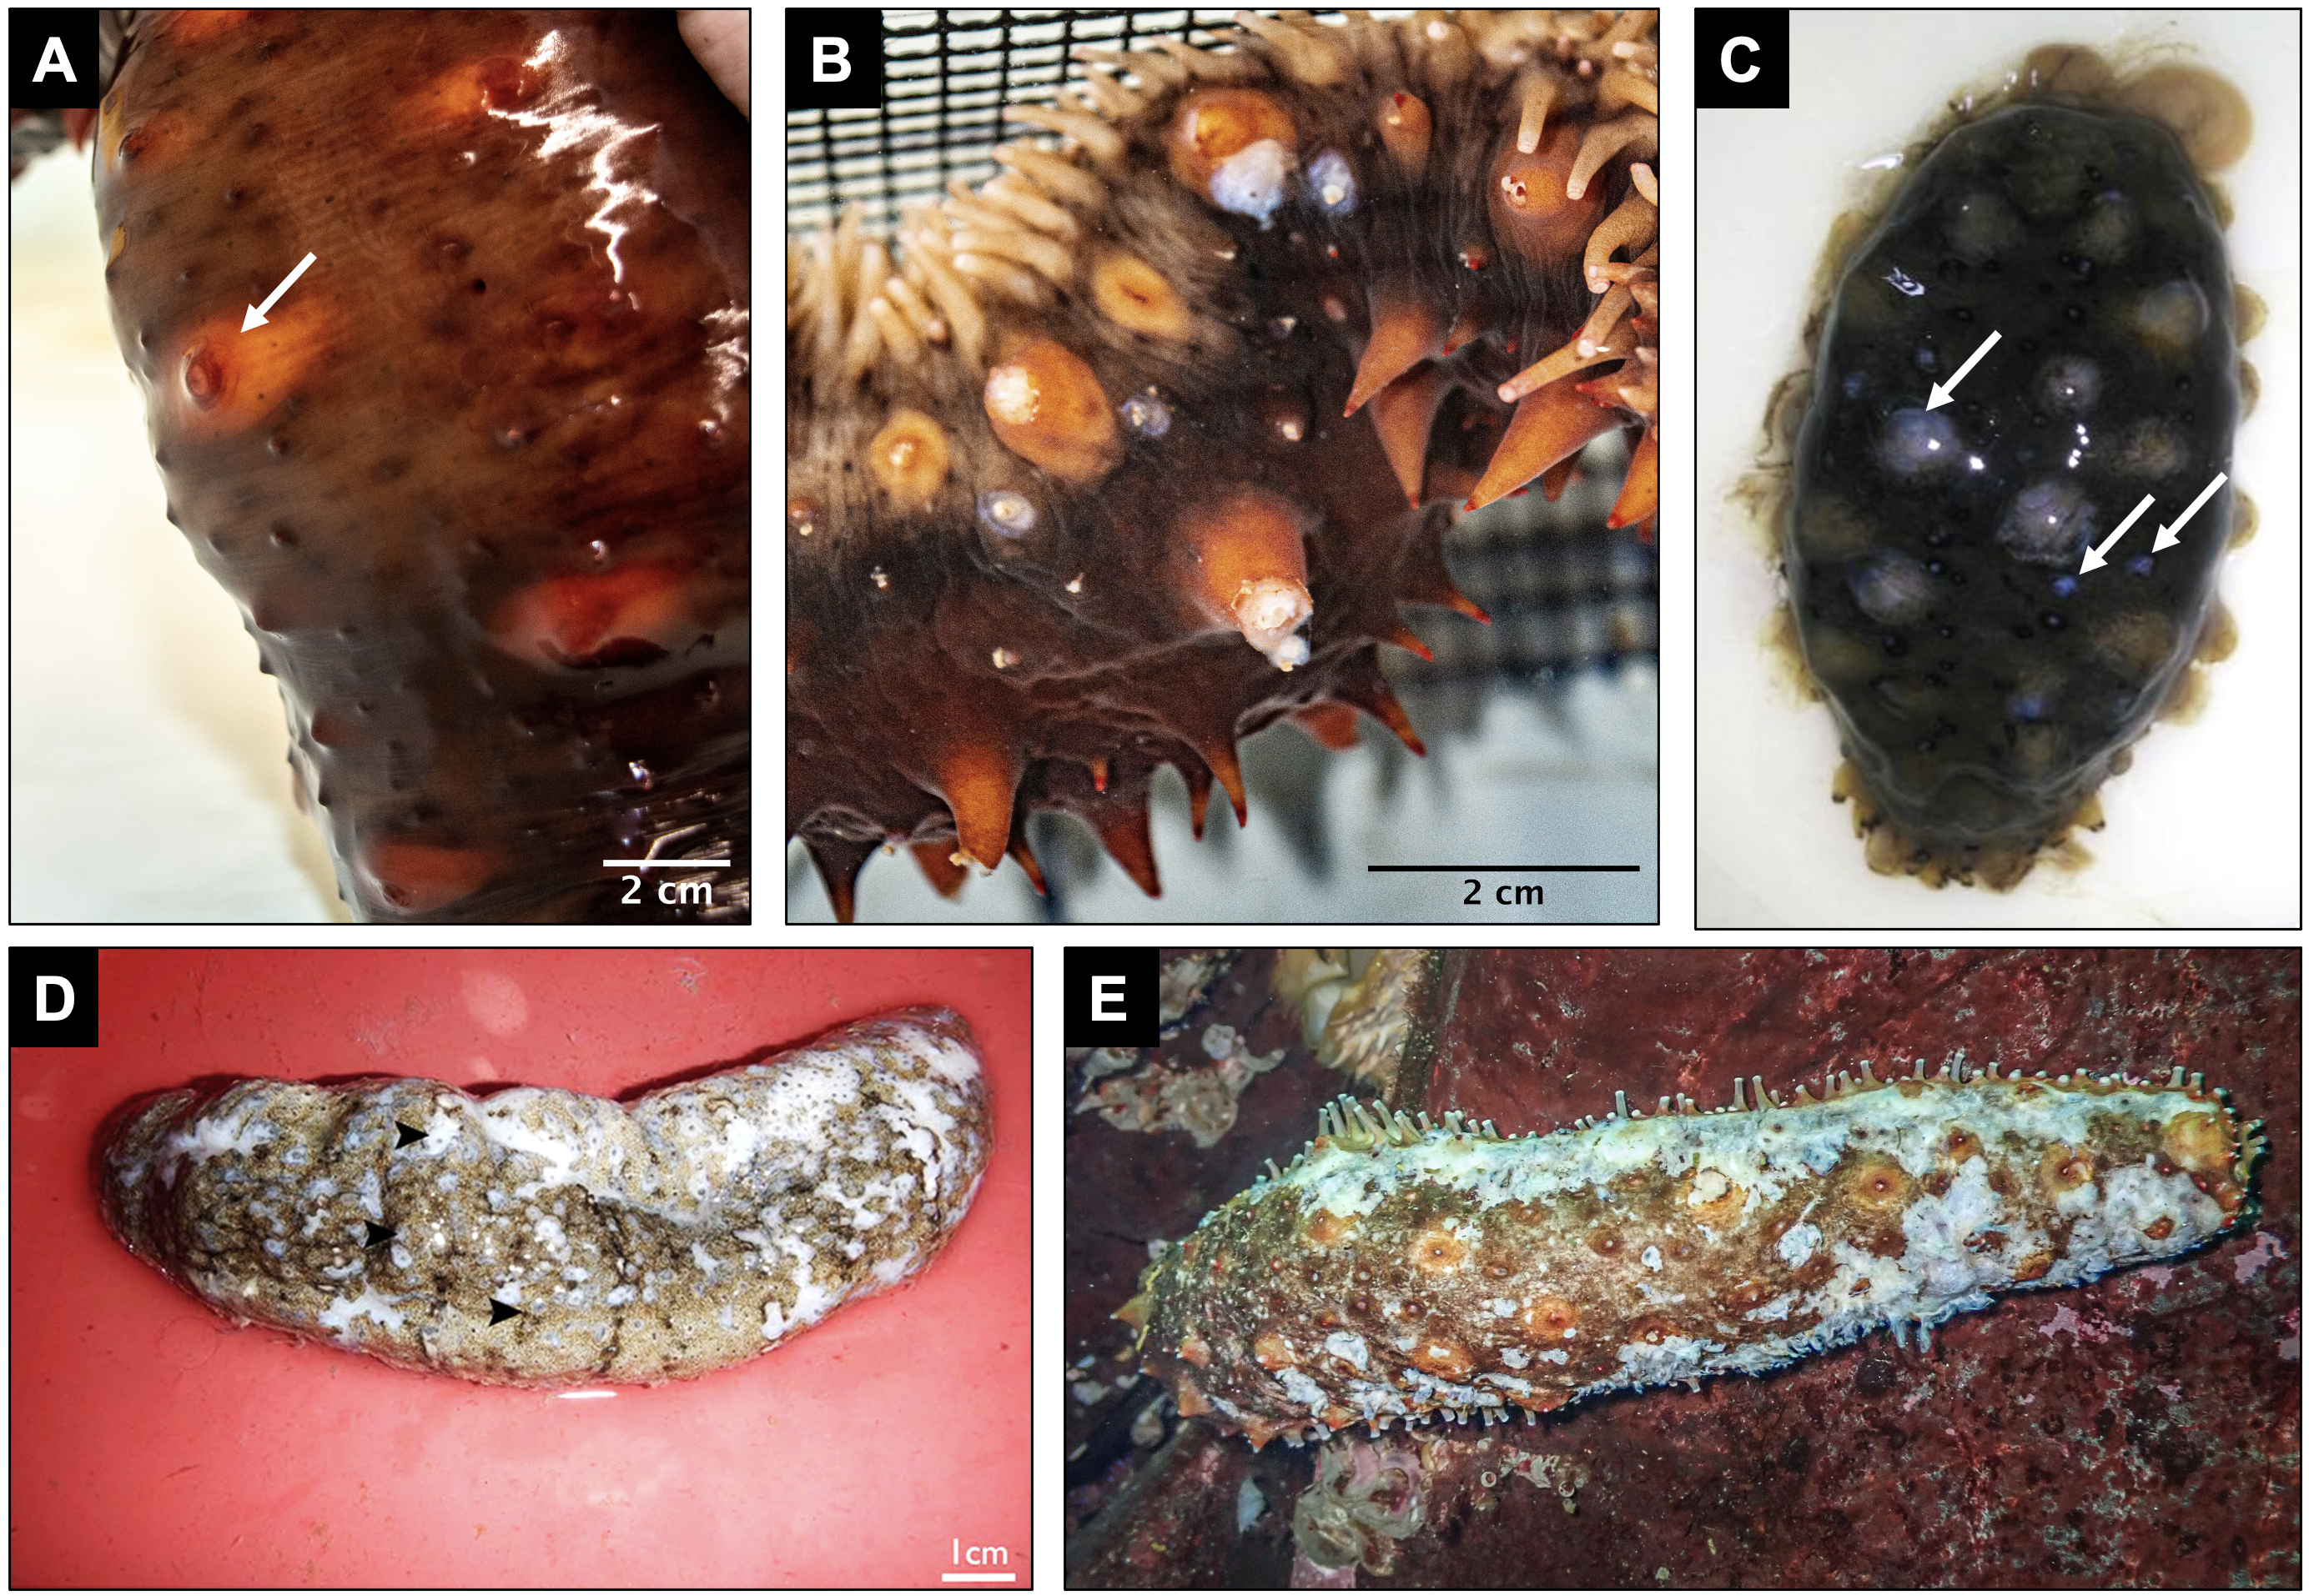

**Figure 2**. *Apostichopus californicus* structural stiffness classifications of soft (A), moderate (B) and stiff (C). Specimens were assigned a stiffness score after being placed in the stiffness testing device and left undisturbed for 5 seconds. Scale bars indicate 2 centimeters.

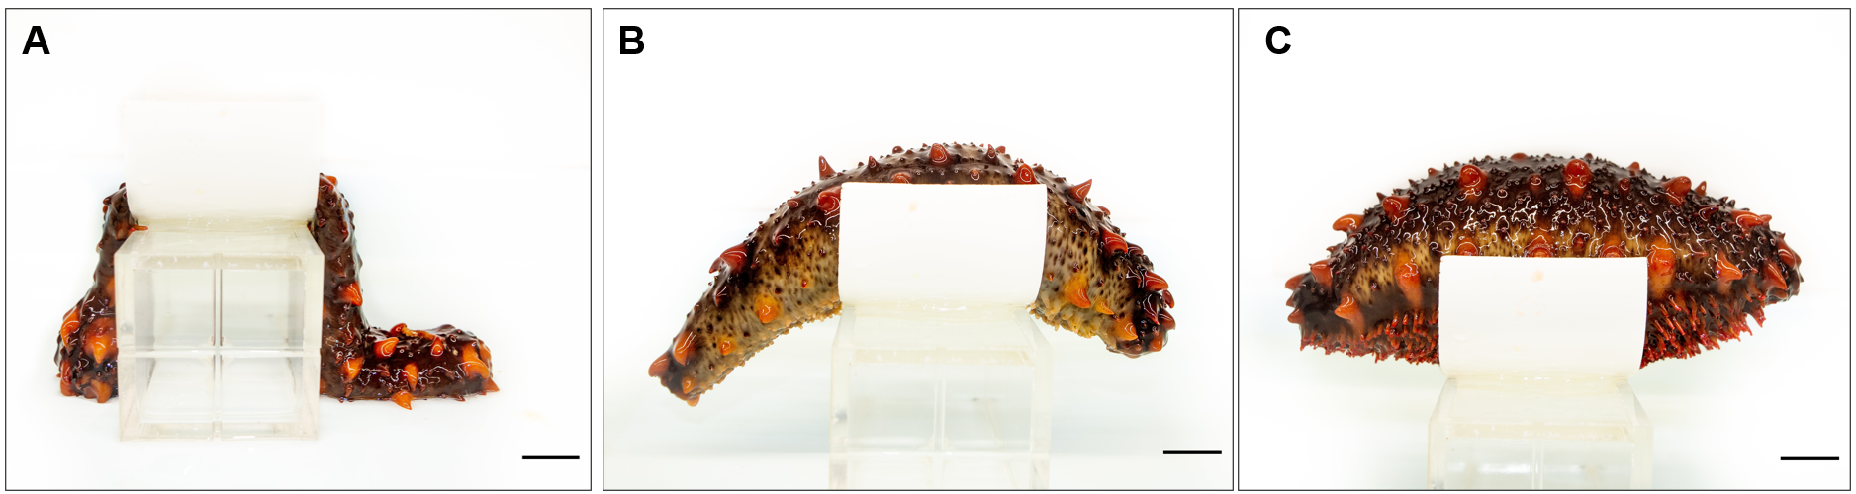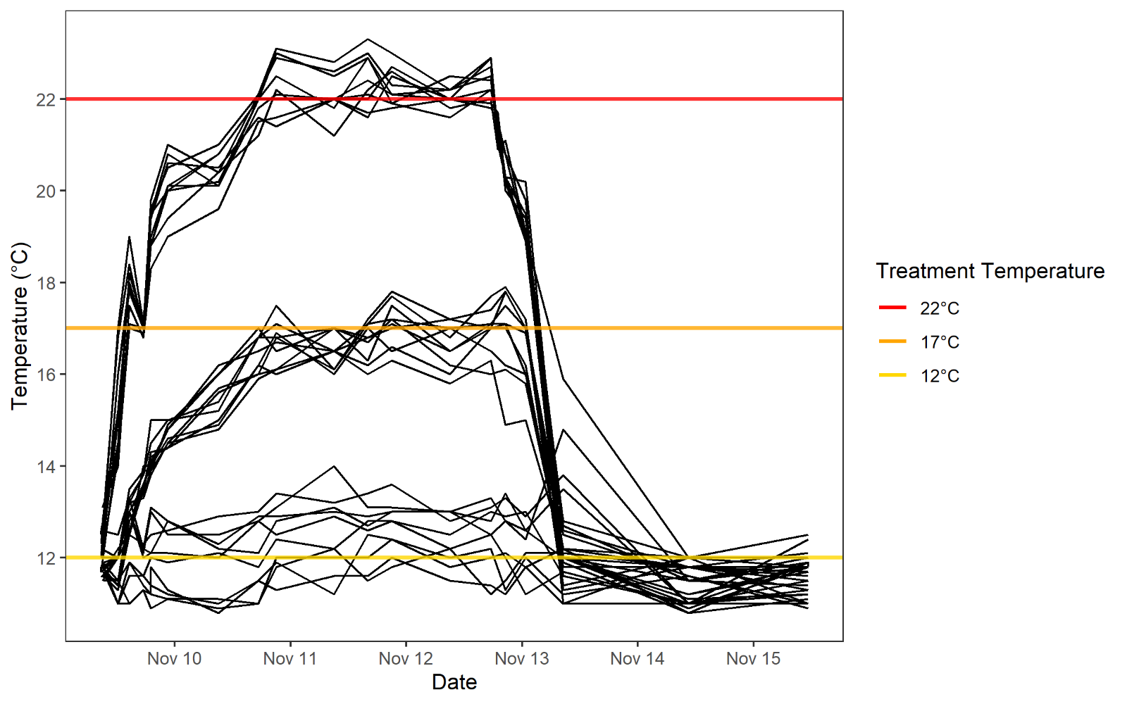

**Figure 3**. Water temperatures in individual buckets over the duration of our experiment. Temperatures were raised over 24 hours from 09:00 on day 1 (Nov 09) to 09:00 on day 2 (Nov 10), and at 16:00 on day 4 (Nov 12) temperatures were gradually lowered until they reached control temperatures at 01:00 on day 5 (Nov 13). Each black line indicates a single bucket housing 1 or 2 *Apostichopus californicus*. The 3 horizontal lines indicate target treatment temperatures. During peak treatment days (2 - 4), temperature treatments were significantly different (K-W χ2 = 463.32, df = 2, p < 2.2e-16).

**Figure 4**. *Apostichopus californicus* stiffness as measured by antipredator defense before (day 1), during (days 2-4), and after (days 5, 7 and 12) the temperature treatment. Dashed lines indicate days where stiffness was measured during target treatment temperatures. Antipredator response was categorized as soft, moderate, or stiff by manually palpating the cucumber to mimic the occurrence of an attempted predation event.

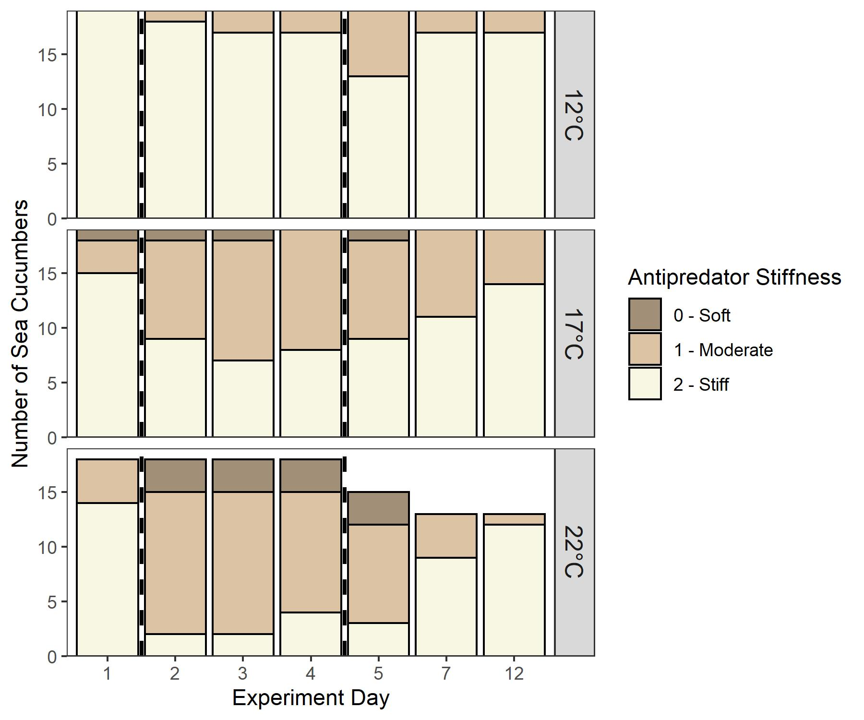

**Figure 5.***Apostichopus californicus* stiffness as measured by postural maintenance before (day 1), during (days 2-4), and after (days 5, 7 and 12) the temperature treatment. Dashed lines indicate days where stiffness was measured during peak treatment temperatures. Posture maintenance stiffness was categorized by placing a stiff cucumber on an elevated platform for 5 seconds and quantifying their posture as soft, moderate, or stiff.

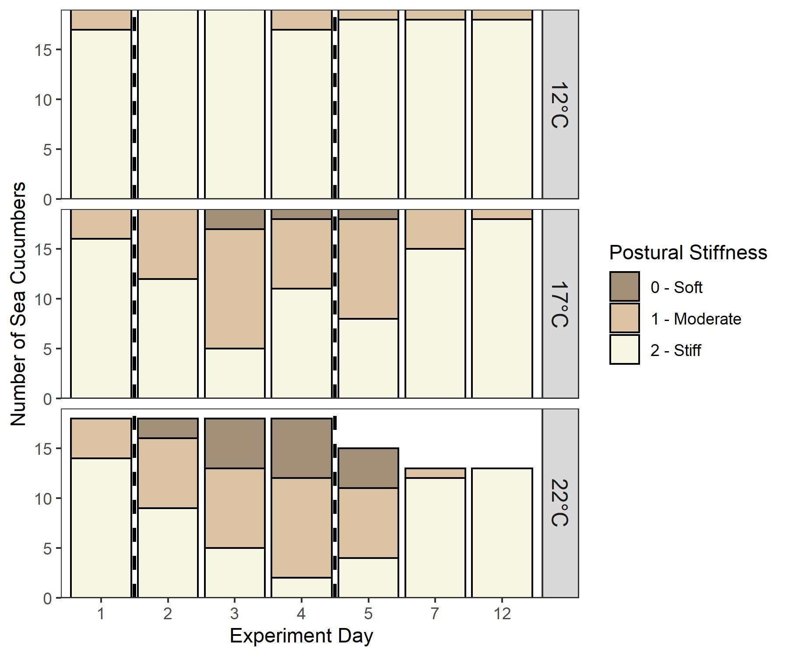

**Figure 6.** The eviscerated digestive tract (A) and respiratory tree (B) of *Apostichopus californicus*in the 22ºC treatment. Respiratory tree (i) and digestive tract (ii) were both eviscerated in panel B. Sea cucumbers frequently expel their digestive tract as a stress response, but respiratory tree evisceration only occurred twice in the 22ºC treatment and was followed by mortality.

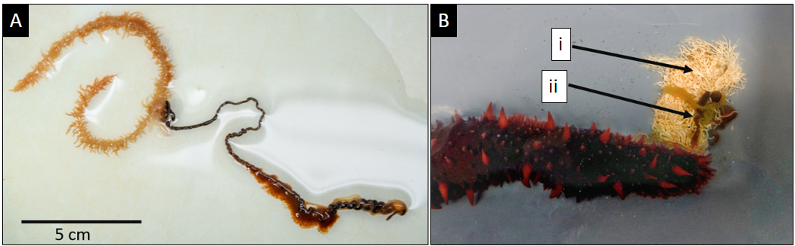

**Supplementary Information**

**Table S1**. Results of ordinal regression model examining the effect of treatment and experiment day on sea cucumber antipredator defense stiffness.

|  |  |  |  |  |
| --- | --- | --- | --- | --- |
| Variable | Coefficient | Std. Error | T | p |
| Treatment: 17C | -3.03 | 0.748 | -4.07 | 4.80e-05 ** |
| Treatment: 22C | -4.76 | 0.818 | -5.82 | 5.88e-09 ** |
| Day 2 | -3.09 | 0.634 | -4.86 | 1.16e-06 ** |
| Day 3 | -3.39 | 0.643 | -5.28 | 1.33e-07 ** |
| Day 4 | -3.00 | 0.632 | -4.75 | 2.06e-06 ** |
| Day 5 | -3.62 | 0.664 | -5.45 | 5.05e-08 ** |

 *p < 0.05, **p < 0.01

**Table S2**. Results of ordinal regression model examining the effect of treatment and experiment day on sea cucumber structural maintenance stiffness.

|  |  |  |  |  |
| --- | --- | --- | --- | --- |
| Variable | Coefficient | Std. Error | T | p |
| Treatment: 17C | -2.99 | 0.575 | -5.20 | 1.99e-07 ** |
| Treatment: 22C | -4.05 | 0.606 | -6.68 | 2.44e-11 ** |
| Day 2 | -0.976 | 0.524 | -1.86 | 0.0627 |
| Day 3 | -2.30 | 0.528 | -4.35 | 1.37e-05 ** |
| Day 4 | -2.22 | 0.527 | -4.21 | 2.50e-05 ** |
| Day 5 | -2.12 | 0.541 | -3.93 | 8.66e-05 ** |

*p < 0.05, **p < 0.01

**Table S3**. Results from a backwards-selected logistic regression model examining the effect of evisceration as a function of defecation status and weight. Asterisks indicate significant effects.

|  |  |  |  |  |
| --- | --- | --- | --- | --- |
|  | Coefficient | Std. Error | t-value | p |
| (Intercept) | 1.713 | 1.128 | 1.52 | 0.135 |
| Defecating (yes) | -2.78 | 1.12 | -2.48 | 0.0163 * |
| Weight | -0.00431 | 0.00203 | -2.12 | 0.0383 * |

*p < 0.05, **p < 0.01

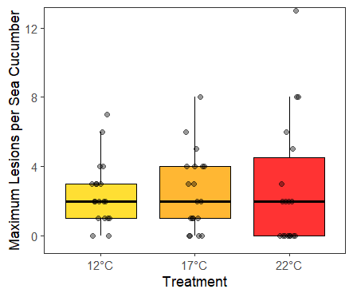

**Figure S1**. Maximum number of minor ulcers found on each individual *Apostichopus californicus* during the heat treatment, compared between the three temperature treatments. We examined specimens for ulcers and classified them as minor or major based on their apparent severity.

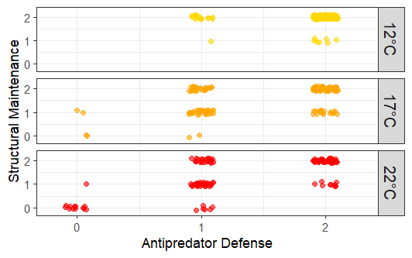

**Figure S2:** Scatter plot displaying the relationship between *Apostichopus californicus* stiffness metrics. Spearman’s rank correlation coefficient indicated a high degree of correlation between metrics (rs = 0.53, p < 0.001). Stiffness metrics were measured daily for each sea cucumber throughout the experiment.

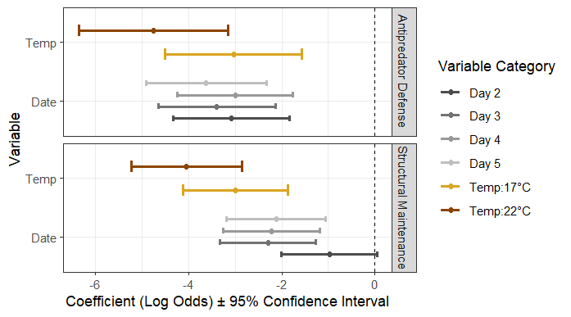

**Figure S3**. Ordinal regression coefficient and 95% confidence intervals from two AIC selected models with stiffness as antipredator defense or structural maintenance as the response variables. Variable reference categories were Temp: 12°C and Day 1. If confidence intervals overlap 0 (dashed line) the effect is non-significant.